|  |  |  |
| --- | --- | --- |
| **LAB 321 Assignment** | **Type:** | **Long Assignment** |
| **Code:** | **J3.L.P0007** |
| **LOC:** | **300** |
| **Slot(s):** | **10** |

**Title:** Supportive learning – Admin site

**Background**

Supportive learning is a system like a course management system, when students can upload the project/assignment/lab to the system, also can see the result. Let’s do the admin site of website.

**Program Specifications**

Program a supportive learning, detail functions of this website is described below

**Features:**

This website contains 04 (six) main functions

* Function 1: Login page ( see figure 01)
* Function 2: Student assignment page (see figure 02)
* Function 3: Assignment management page (see figure 03)
* Function4: FAQ management page (see figure 04)

Note: All data must be load from database, not hard code.

***Expectation of User interface:***

Pic 01: Login Page ( TOP)

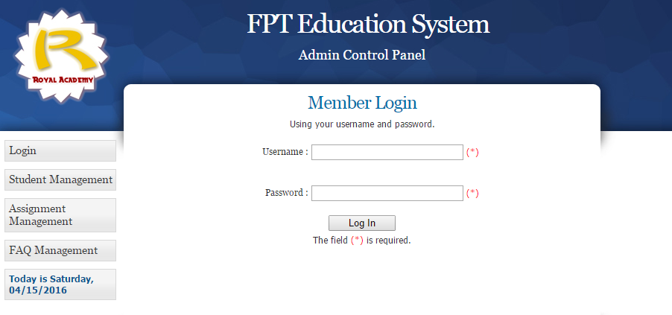

PIC 02: Student management Page

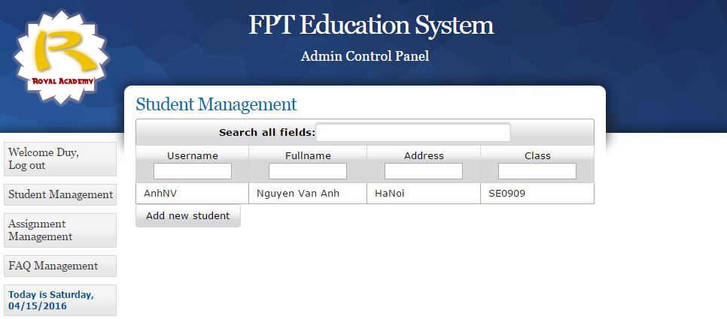

Pic 03: Assignment management Page

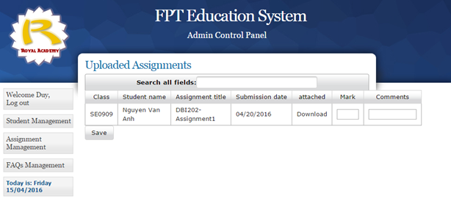

Pic 04: FAQ management Page

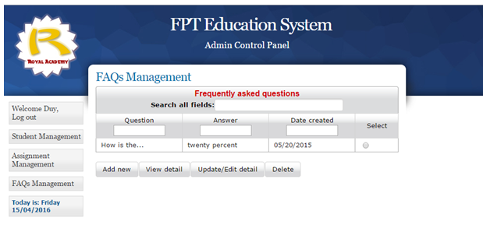

**Guidelines**

* Step 1 : Create prototype
* Step 2 : Design database base on created prototype
* Step 3 : Code & Test